ROCKY HALL CEMETERY HERBS OF CONSERVATION SIGNIFICANCE

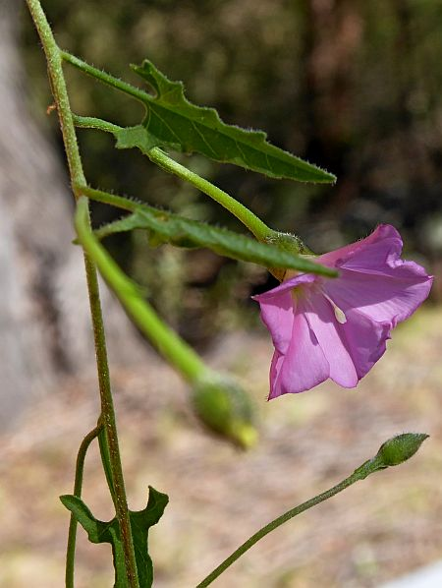 | 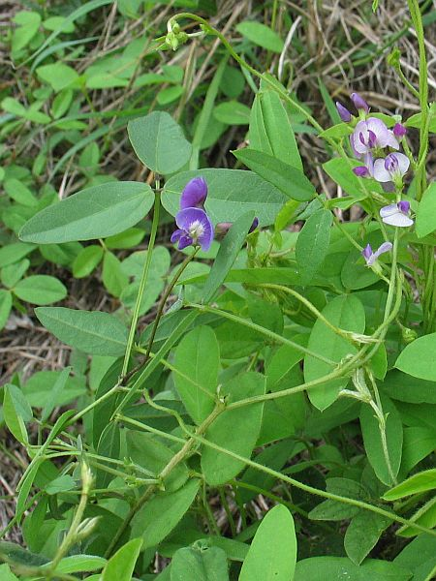
Native Bindweed (Convolvulus angustissimus) | Twining Glycine (Glycine tabacina)
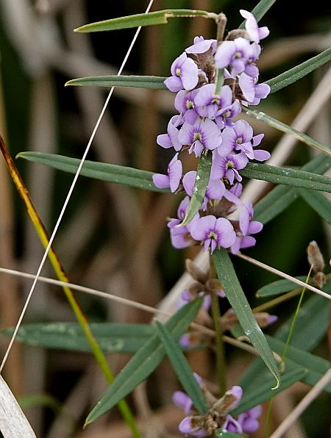 | 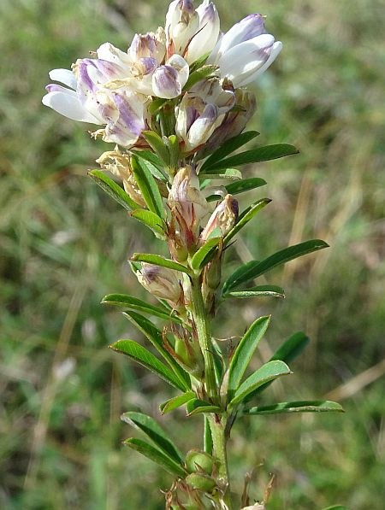
Small Hovea (Hovea heterophylla) | Lespedeza (Lespedeza juncea)
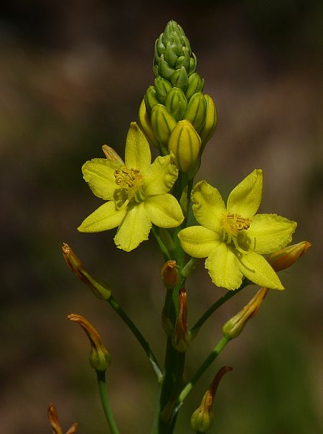 | 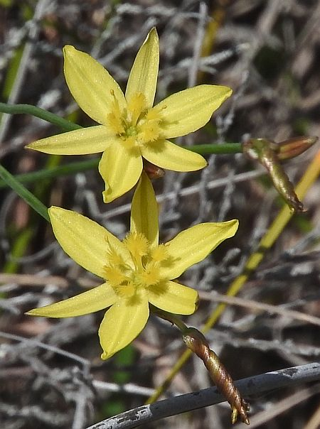
Bulbine Lily (Bulbine glauca) | Yellow Rush-lily (Tricoryne elatior)
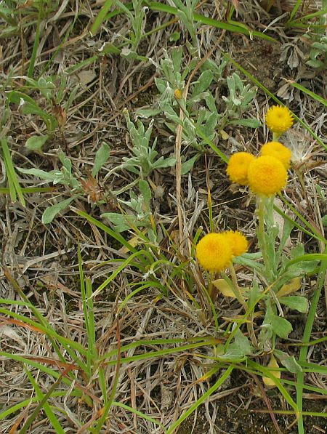 | 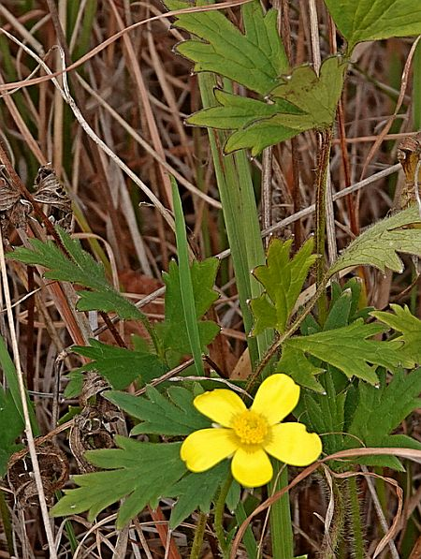
Yellow Buttons (Chrysocephalum apiculatum) | Forest Buttercup (Ranunculus lappaceus)
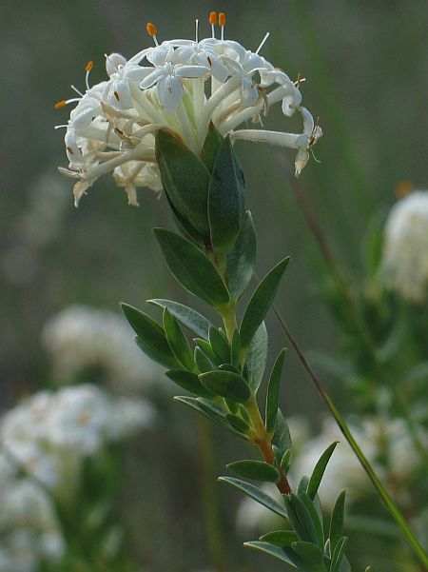 | 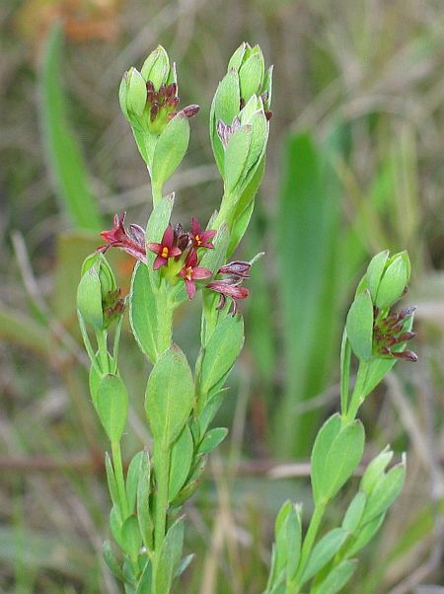
Blue Rice-flower (Pimelea glauca) | Tiny Rice-flower (Pimelea curviflora var. sericea)
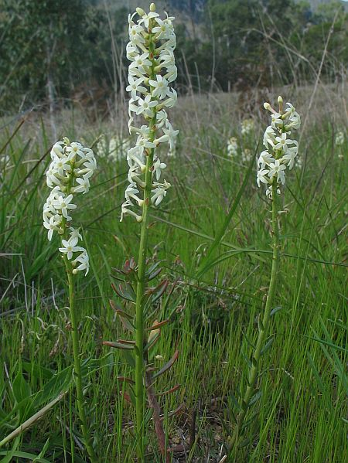 | 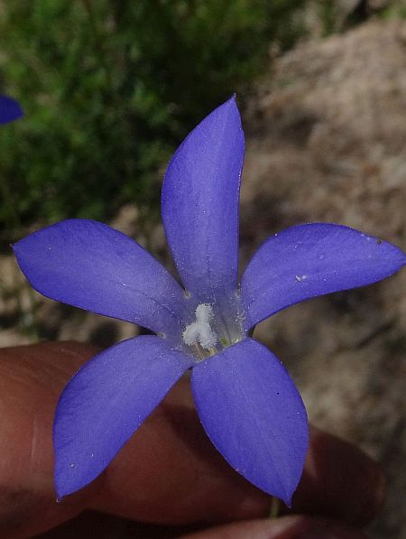
Creamy Candles (Stackhousia monogyna) tablelands form | Native Bluebell (Wahlenbergia stricta), not uncommon but one of 4 bluebells at Rocky Hall cemetery, an unusual number of species to find in one place.
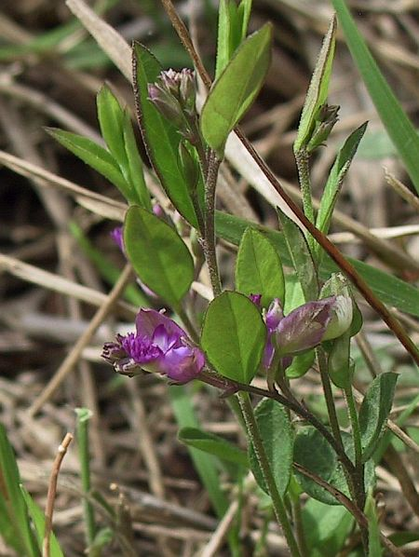 | 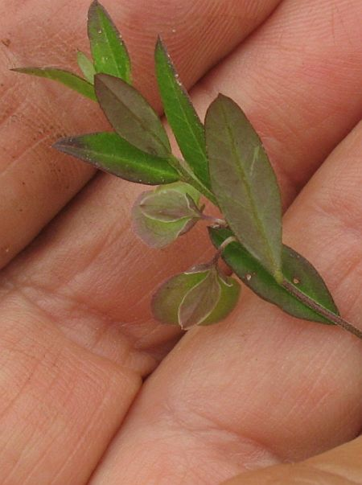
Polygala (Polygala japonica) flowers | Polygala (Polygala japonica) fruits
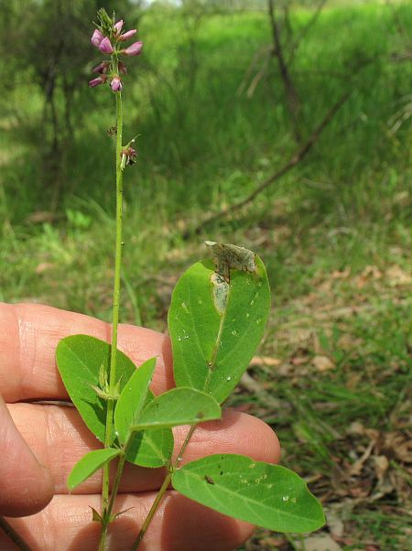 | 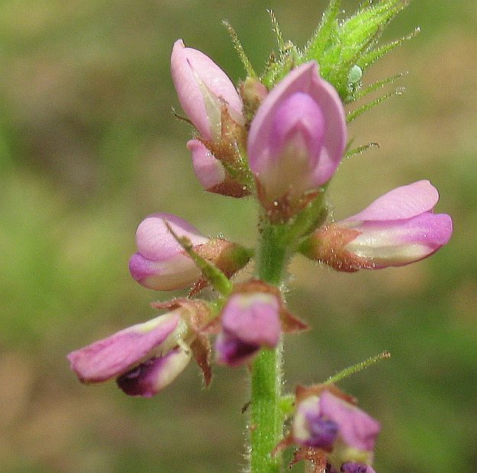  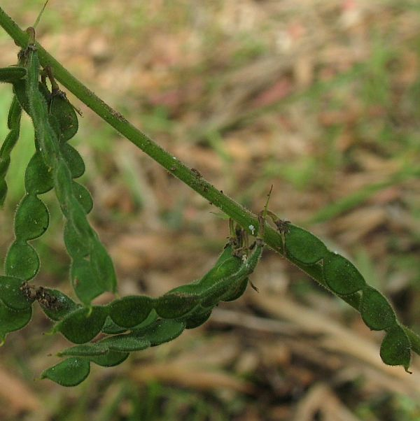
Large tick-trefoil (Desmodium brachypodum) | D. brachypodum flowers and fruits

